TED ISTANBUL MODEL UNITED NATIONS

INFORMATION
BOOKLET
INDEX

Letter from the Secretary-General………………………………….……..……1

Provisional Schedule………………………………………………..………….…2
Committees……………………………………………………………...….……...3
Locations…………………………………………………………….………...…5
School Map………………………………………………………………………6
Workshops/Guest Speakers……………………………………….………….7
The Executive Team…………………………………………………….………10
Our Directors…………………………………………………….…………….…12
General Information…………………………………………………………….13
Rules of Procedure……………………………………………………….…….15
Writing A Resolution…….………………………………………………….….17
Sample Resolution……………………………………………………………..18

LETTER FROM THE SECRETARY-GENERAL
Distinguished Directors and Esteemed Participants,

On behalf of the Executive Team, I am honored to have the privilege of welcoming you to our third official session of the TED Istanbul Model United Nations (TEDIMUN), which will be held on January 13-14-15, 2023. Inspired by the ongoing change in our world, our upcoming conference will take place with the theme of “Shifting Tides: Striving for Change in the Modern World.”
I believe our team's previous years of experience have provided us with the necessary tools to make TEDIMUN'23 a memorable experience, and we are delighted to get to share these three days with you.

The theme of TEDIMUN’23 focuses on the ever-present aspiration for change in our modern world. We believe in the aptness of this theme for our continuously evolving political landscape, and our eternal quest to be better. Our world is constantly shifting between societal norms and forward-thinking, progressive ideas. This current generation will inadvertently have a major influence on these shifts. As such, MUN is certainly an opportunity to explore the differing perspectives on change, and the spectrum of ideas that occupy this broad and expansive topic. Challenging the status quo and embracing modernity is a trait I hope all participants will gain moving forward. Our responsibility to the future by heralding the change to better it is why we believe this theme to be fitting for TEDIMUN'23.

As the ambitious Secretariat of TEDIMUN’23, we aim to provide an eye-opening experience for all participants with our challenging and thought-provoking agenda items. We hope to see lucrative and well-formed debates taking place within our sessions. Our hardworking and committed Executive Team will do everything within their power to create a truly remarkable atmosphere. I look forward to seeing innovative ideas from our diligent delegates and hope to find that all participants will have gained a new outlook on our modern world, how we can adapt to changes within it, and how to evolve alongside those changes.

I am excitedly waiting to meet you at TEDIMUN'23 which will surely be an incredible experience for all of our participants.

Cordially,

Simay ÖZGENTÜRK
Secretary-General of TED Istanbul Model United Nations 2023

PROVISIONAL SCHEDULE

Friday, January 13th
13:45 - 14:30 Registration
14:30 – 15:45 Opening Ceremony
15:45 - 16.00 Coffee Break
16.00 – 17.30 Committees in session
17.30 – 17:45 Coffee Break
17:45 – 18.45 Committees in Session
18.45 – 19.00 StOff Debriefing

Saturday, January 14th
09.45 – 10.00 StOff Briefing
10.00 – 11.30 Committees in session
11.30 – 11.45 Coffee Break
11.45 – 12.30 Committees in session
12.30 – 13.45 Lunch
13.45 – 15.00 Committees in session
15.00 – 15.15 Coffee Break
15.15 – 16.45 Committees in session
16.45 – 17.00 StOff Debriefing
17.45 - 21.45 Social Event

Sunday, January 15th
09.45 – 10.00 StOff Briefing
10.00 – 11.30 Committees in session
11.30 – 11.45 Coffee Break
11.45 – 13.15 GA in session
11.45 – 13.15 SC and UNODC in session
13.15 – 14.30 Lunch
14.30 – 15.45 GA in session
14.30 – 15.45 SC and UNODC in session
15:45 – 16.00 Coffee Break
16.00 – 17.30 GA in session
16.00 – 17.30 SC and UNODC in session
17.30 – 17.45 Coffee Break
17.45 - 19.00 Closing Ceremony

2
COMMITTEES

General Assembly 1 – International Security & Disarmament (GA 1)
President Chair-Mert Özden
Deputy Chairs-Yağmur Eda Yıldız, Duru Öztürk
- Preventing the financing and the trafficking of the illicit arms trade in West Africa
- The issue of mass destruction due to biological weapons in middle eastern countries

General Assembly 2 – Economic & Social Council (ECOSOC) (GA 2)
President Chair-Kerem Moğol
Deputy Chair-Peri Kunt
- The issue of promoting circular economic principles
- The issue of combating income inequality by gender on a global scale

General Assembly 3 – Social & Humanitarian (GA 3)
President Chair-Defne Irmak Yurt
Deputy Chairs-Büşra Koyuncu, Kerem Güngör
- The issue of the Anglophone crisis in Cameroon
- The issue of protecting native tribes within the Amazon rainforest

General Assembly 4 – Environmental (GA 4)
President Chair-Ada Han Yeşil
Deputy Chair-Alp Cepni
- The issue of prevention of global microplastic pollution
- The issue of financing the adaptation to climate change in LEDCs

COMMITTEES

General Assembly 5 – Legal (GA 5)
President Chair-Menekşe Ezgi Akyol
Deputy Chairs-Gökçe Aydın, Nehir Yılmaz
- Question of U.S. policies and military presence in the Black Sea and littoral countries
- Ensuring the human rights of the Palestinian people and other Arabs of the occupied territories.
​

United Nations Office on Drugs and Crime (UNODC)
President Chair-İpek Öner
Deputy Chair-Dilay Mehmetoğlu
- The issue of transnational organized crime
- The issue of illicit drug trafficking among Latin American cartels

Security Council (SC)
President Chair-Kaya Altuntaş
Deputy Chair-Deniz Kavak
- The issue of ensuring civilians’ safety during peacekeeping operations
- The issue of America's exit from Afghanistan

LOCATIONS

Committee/Event Location
Opening/Closing Ceremony, GA Plenary, Registration | Conference Hall
Team Building | Front Garden
Social Event / Coffee Break | Ground Floor
GA1 | Nazım Hikmet
GA2 | 11A
GA3 | 11B
GA4 | 11C
GA5 | 11D
SC (Security Council) | 11E
UNODC (UN Office on Drugs & Crime) | 11F
Admin Room | 10A
Approval Panel | 10B
Luggage Room | Kulis 1 Room
Advisors Room | Library

SCHOOL MAP

High-School Building-Area in Use

WORKSHOPS
StOff Workshop-January 14th, 17:15
Nil Süme and Burcu Birler

Nil Süme and Burcu Birler are both responsible for major contributions made within this conference. Both with their respective roles, as Head of Admin and Deputy Secretary General, will be providing future StOff members with the necessary information to make them qualified within their positions. Their goal is to make this conference an enjoyable and seemingly worthwhile experience for delegates who are wishing to gain knowledge on how to serve as a StOff member. There will be limited attendance to the workshop, and an attendance form will be shared with all delegates. We hope to see you join and gain important knowledge to help you with your future experiences!

7

GUEST SPEAKERS
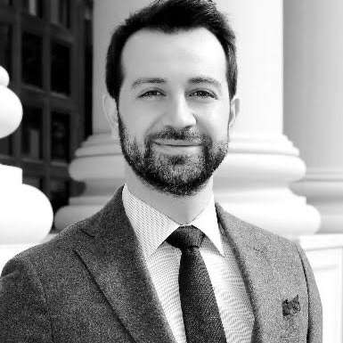
Esat Uğurlu
Esat Uğurlu is the founder of Globed, an e-learning company with over a million active users. He graduated from Brandeis University in 2006, after which he began his career in Massachusetts, USA. He has worked under several Fortune 500 companies, showcasing his credibility within the global market. Most importantly, he moved to Thailand in order to work at UNESCO, particularly under Education for Sustainable Development, demonstrating his apparent interest in education. Throughout his career not only in his initial location, Massachusetts but also in Bangkok and his current place of residence, Istanbul, he has internalized many aspects of what makes up one’s ability to learn universally. He has managed to digitize learning on a global scale through Globed, which is now in its eleventh year and currently spread out in Turkey, UAE, and Romania.

Lara Öge
Lara Öge is a former TED Istanbul College with many contributions to this conference and the MUN scene. She graduated from TED Istanbul last year and is currently working on getting her bachelor’s from UC Berkeley. She is double majoring in neuropsychology and music. Her role within previous TEDIMUN conferences has been unparalleled, especially due to her roles in the previous executive teams. She has participated in many MUN conferences throughout the country, making her renowned among students partaking in said conferences.

8

THE EXECUTIVE TEAM

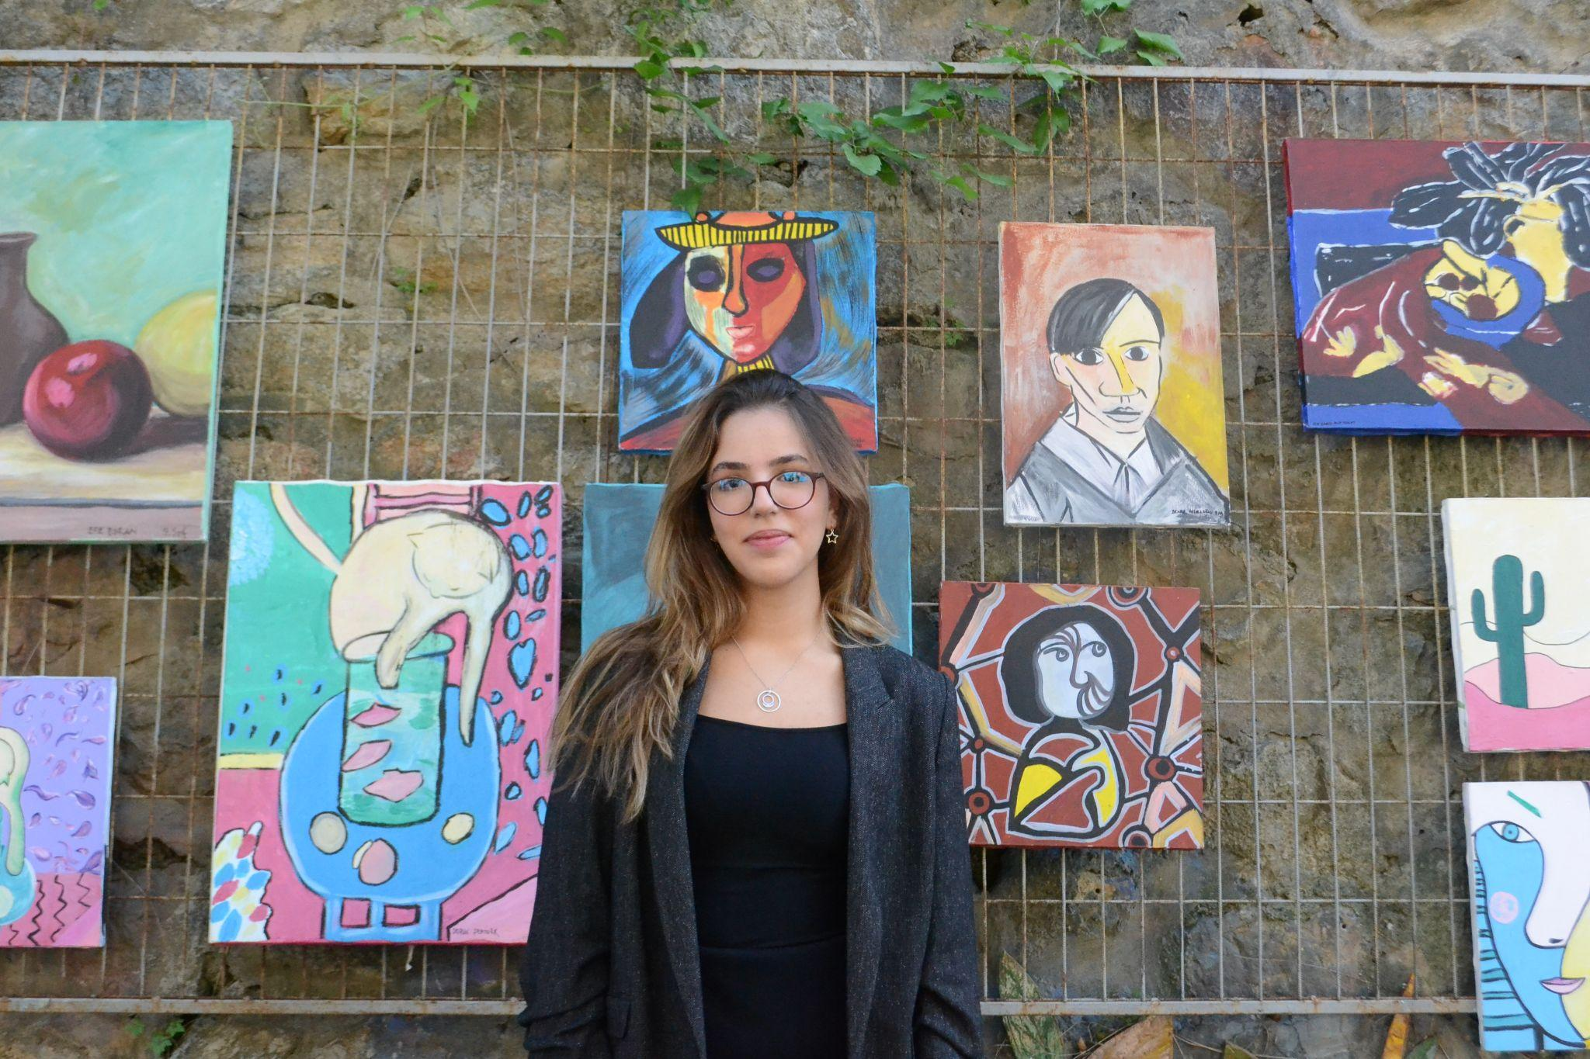

Secretary-General President of the General Assembly
Simay Özgentürk Melissa Çevikel

Deputy Secretaries-General
Burcu Birler & Gamze Yüncüoğlu

9

THE EXECUTIVE TEAM

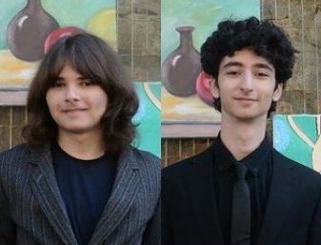

Heads of Approval Panel Head of Admins
Asya Ateş & Selim Birler Nil Süme

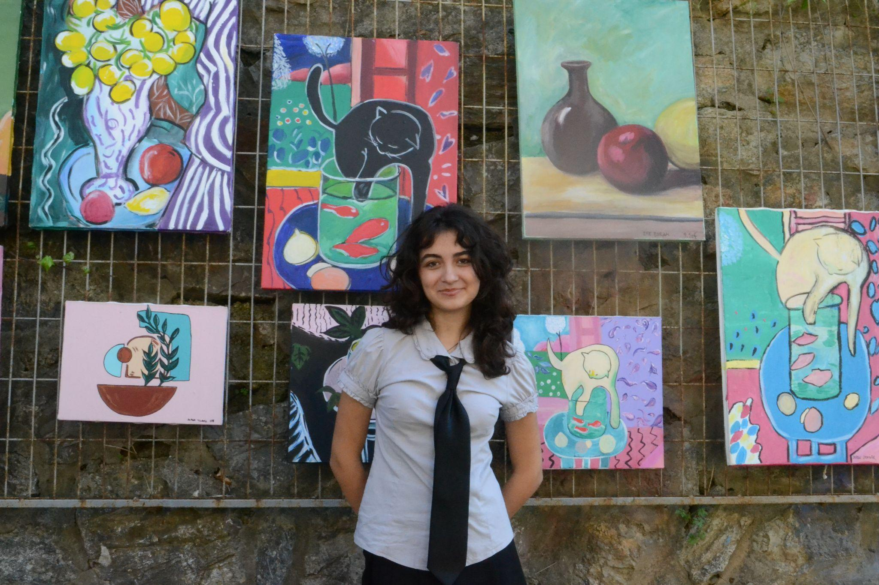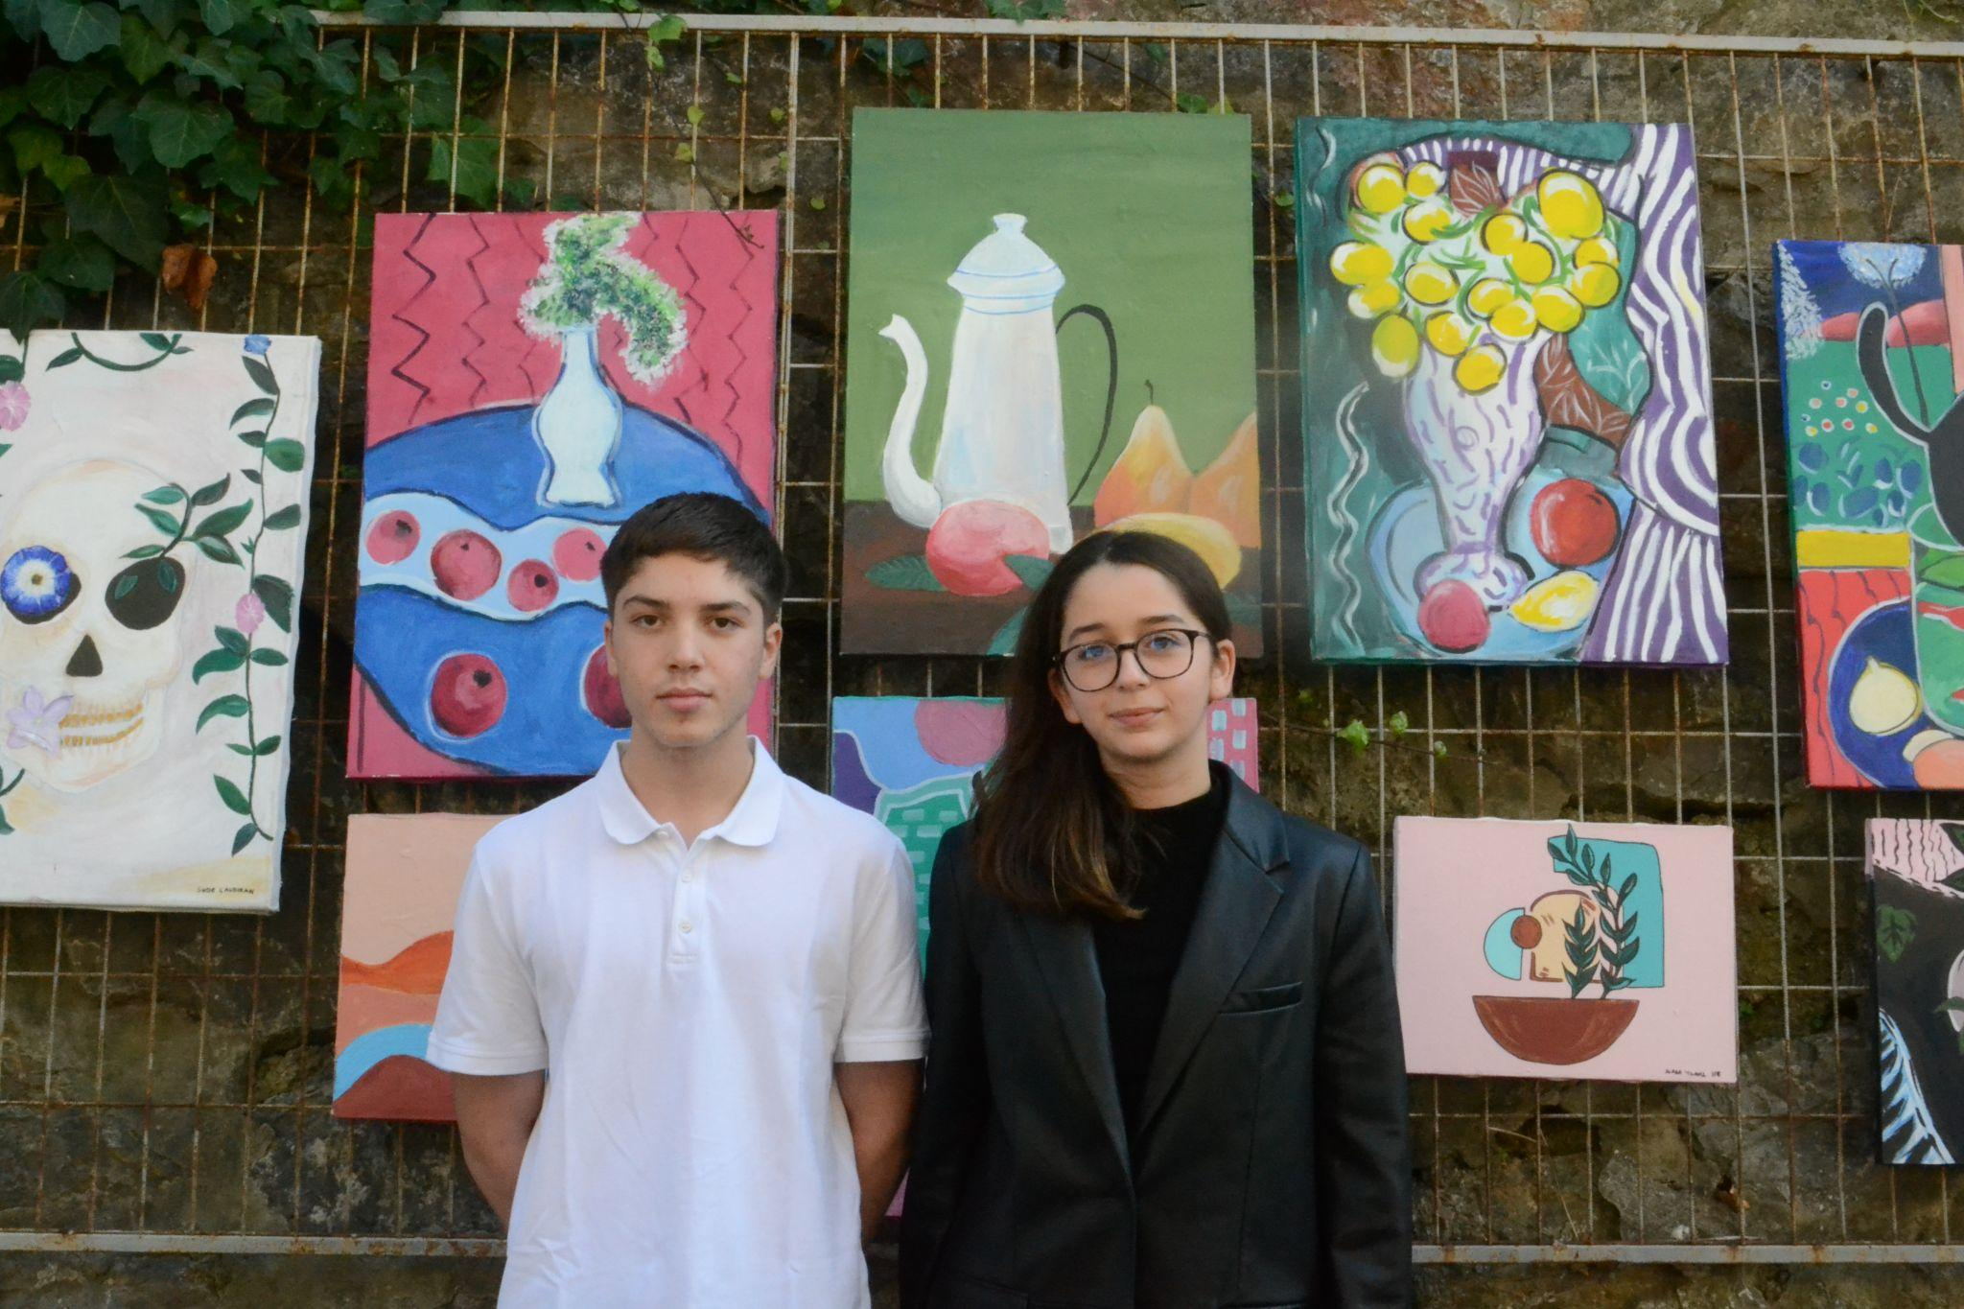

Head of Press Heads of Finance
İrem Anık Defne Irmak Yurt & Mert Özden

10

OUR DIRECTORS

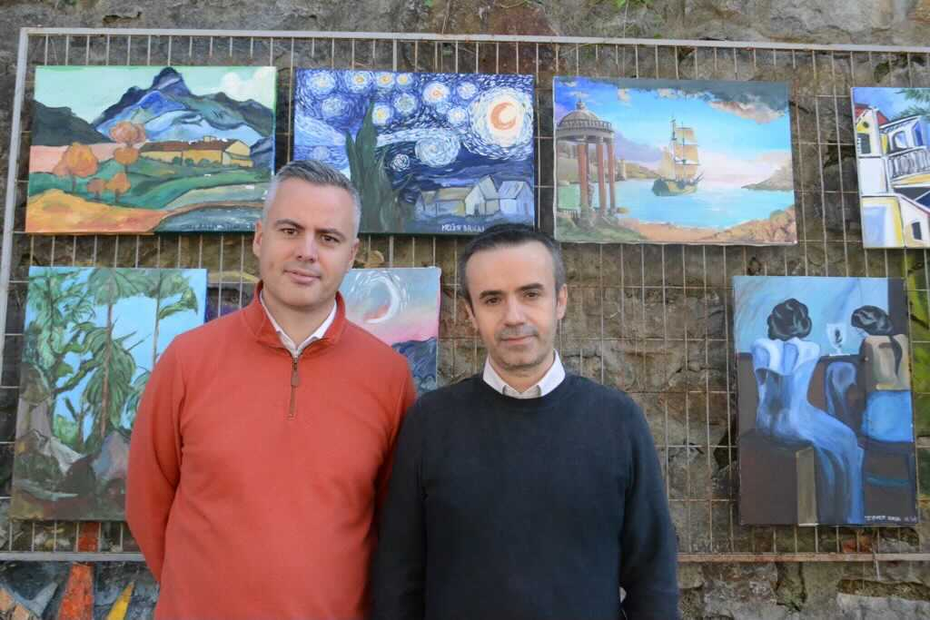

Nedim Özer & Chris Sweeney

11

GENERAL INFORMATION

Cell Phones
Cell phone use is only allowed during lobbying sessions, for research purposes only. Other than that, cell phones are to be switched off during all TEDIMUN sessions and ceremonies. Cell phone usage will be observed and checked by admins at all times, and advisors will be notified in case of inappropriate use.

Dress Code
Since TEDIMUN is a formal conference, formal attire is mandatory. Male participants must wear a suit and a tie and female participants must wear clothes that are equal in formality.

Executive Staff
The TEDIMUN Executive Staff is the main team that is responsible for the conference. For any of your questions or concerns, you may approach an admin, a StOff member or any executive team member at any time.

Food
Lunch will be served on the 14th and 15th of January in the cafeteria.

Health
There is an infirmary on the school campus where you can go in case of an emergency.

Internet
There is WIFI service inside the campus. You will need to sign up as “GUEST.”

Laptops
Laptops are allowed during TEDIMUN.

Lobbying
This is the time where you can talk to other delegates in your committee about the issues, and share, write or merge clauses/resolutions. The chairs will decide the time for lobbying in each committee.

Note Passing
Note passing is in order during committee sessions. All note passing should be done in English, and should concern the debate. Admins will be checking the notes before passing them on.

Placards
Placards with your country will be given to you at the beginning of the conference. If you lose your placard, you are to pay a fee of 40 TL.

Smoking/Alcohol/Drugs
Smoking, alcohol and drug use is strictly prohibited during the TEDIMUN conference and social event. The usage of such substances will result in the student being requested to leave the conference, effective immediately.

Plagiarism
Every section of submitted resolutions will be checked for plagiarism, and advisors will be notified. Preambulatory clauses are not exempt from this rule.

Resolutions
Delegates are expected to have a pre-written resolution on one of the agenda items of their committee in order to have more productive lobbying sessions.

Position Papers
Delegates are encouraged to write a position paper regarding their delegation’s policies.

13
RULES OF PROCEDURE

There are specific rules all delegates and chairs must follow while debating. If you are unfamiliar with these, keep on reading…

WHILE SPEAKING…
All delegates and chairs should refrain from using personal pronouns (I, you, him, her, they, etc.).
Delegates may use pronouns such as “we” (referring to their country representatives) and refer to themselves and others as the delegate/delegation (of country).

Starting a speech | “Distinguished Chairs, fellow delegates…”
Referrals | “We believe that…”  “The delegate of Turkey thinks that…”  “The delegate agrees with the delegation of France.”

Yielding the floor is necessary after the delegate has finished speaking. The delegate will either yield the floor to the Chair or to another delegate.

POINT OF…
Delegates rise to points when they request a change or when they want to ask a question.
NOTE: The ONLY point that may interrupt the speaker is a point of privilege due to audibility.

Point of Personal Privilege: A personal request to change something that is an inconvenience to the delegate (temperature of room, loudness of speaker, etc.).

Point of Order: This refers to the procedure of the debate. Its usage is appropriate if the chair makes an error about the debate time or the order of debate.

Point of Information Directed to the Chair: A question directed to the chair that may be about anything that is on the delegate’s mind. If they need to know information about lunch times to directions, in case of any question or concern, they should introduce this point.

14

RULES OF PROCEDURE

Point of Information Directed to the Speaker: A question asked to the delegate who has the floor. A delegate may only ask a point of information if it is recognized by the chair. Delegates may only ask one point of information.
The chair must first ask the delegate if they are open to any points of information.
The questioner may not speak again once the speaker has answered. FOLLOW UPS are only allowed if the chair approves it.
Examples | “Is the delegate aware of the fact that…”  “Would the delegate of Germany agree that…”  “Does the delegate (not) think that…”
NOTE: Direct dialogue is not allowed between delegates.

Point of Parliamentary Inquiry: A question asked to the chair about the rules of procedure.

MOTION TO…
Motions are requests introduced that need to be “seconded” by other delegates. If there are any objections in the House, the motion will not be in order or will be voted upon.

Motion to Move to the Previous Question: This motion calls for the voting of the resolution at hand. If it is believed that there are no further adjustments that need to be made to a resolution/clause, delegates should shout out this motion.
If there are no objections and the majority of the House “seconds”, it will be in order.

Motion to Extend Debate Time: If debating time has come to an end, however a delegate feels enough hasn’t been said about the resolution, they may request to extend the debate time with this motion.

Motion to Divide the House: When the House votes upon a resolution, and the votes in favor and against are very close, this motion can be introduced. Dividing the House means every delegate is individually asked to answer either “in favor” or “against,” and there can be no abstentions. Since this is a very time-consuming motion, the chair will for the most part not allow this motion.

Motion to Table the Resolution: If the delegate believes that the resolution should temporarily be not discussed and saved for later, they can request to table the resolution. This motion is mostly overruled by the Chair, however if the chair allows it and the majority of the House agrees, the resolution will be put on hold.

Motion to Adjourn Debate: This motion calls for a break from the debating time. The delegate should add the amount of time they want to adjourn.
15

WRITING RESOLUTIONS

When writing a resolution, delegates should refer to this list of perambulatory and operative clauses.

Preambulatory | Operative
Reaffirming  Realising  Recalling  Recognising  Referring  Reminding  Seeking  Stressing  Taking into consideration  Taking note  Affirming  Alarmed by  Approving  Aware of  Bearing in mind  Congratulating  Deeply concerned  Emphasizing  Expressing its concern  Fully alarmed  Fully aware  Further recalling  Having considered  Having considered further  Keeping in mind  Noting  Noting further  Recognizing | Accepts  Affirms  Approves  Asks  Authorises  Calls for  Calls upon  Confirms  Emphasizes  Encourages  Endorses  Regrets  Requests  Resolves  Seeks  Stresses  Strongly affirms  Strongly urges  Suggests Supports Trusts  Urges  Strongly condemns*  Condemns*  Demands*
*Only to be used by the members of the Security Council.

AMENDMENTS…
Amendments are a very important part of the debate procedure. If the delegate believes they can improve the resolution, they submit amendments.
Amendments can be submitted to strike out, change, insert or add to a specific part of the resolution. Friendly amendments (grammar and punctuation changes) will not be entertained at TEDIMUN.

16

SAMPLE RESOLUTION
*Via THIMUN

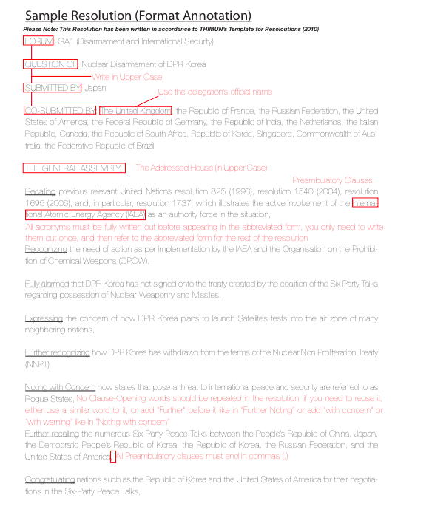
17

SAMPLE RESOLUTION
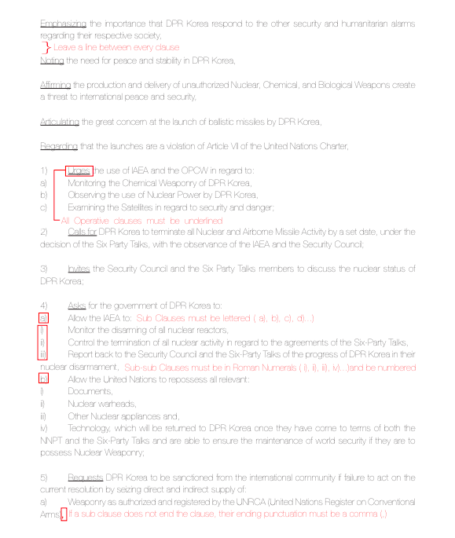
18

